Professional Portfolio:
An interview with Dana Alexander

Morgan Eubanks
ENC 3202: Professional Communication for Business
Dr. Berry
November 8th, 2025

Executive Summary
This report examines the accounting profession through the lens of both industry analysis and professional experience, focusing specifically on Carr, Riggs & Ingram (CRI), one of the largest accounting firms in the United States. Accounting remains a vital and stable career path due to its importance in financial accuracy, ethical reporting, and organizational accountability. With advancing technology and evolving financial regulations, today’s accountants must not only master technical and analytical skills but also maintain strong communication and problem-solving abilities to serve clients effectively.
Carr, Riggs & Ingram (CRI) exemplifies how mid-to-large firms thrive through adaptability, client relationships, and service diversity. Founded in 1997, CRI has expanded to more than 30 states and even internationally, offering services in audit, tax, advisory, and specialized consulting such as forensic accounting and cybersecurity. Generating over $300 million in annual revenue and employing more than 2,000 professionals, CRI ranks among the Top 25 accounting firms in the nation (Zippia, 2025). The firm’s strength lies in its ability to serve a wide range of industries, including nonprofit, healthcare, government, and construction, while maintaining personalized client care that differentiates it from the larger “Big Four” firms.
The accompanying writing samples highlight the same professionalism and attention to detail found in accounting work. Each piece demonstrates clear organization, factual accuracy, and effective communication, skills that mirror the documentation, reporting, and client correspondence expected in the accounting field. Together, the research, interview, and writing samples show that successful accountants must combine technical expertise with strong writing and interpersonal communication to maintain integrity and client trust.
Table of Contents
Executive Summary 1
The Accounting Industry 3
The Health and Size of the Accounting Industry 3
Legal and Ethical Concerns 4
AI in Accounting 6
Diversity in Accounting Firms 8
Car, Riggs, & Ingram (CRI) 10
The History of CRI 10
Services Provided 11
Firm Size 13
Interview 15
Sample Writing 19
Sample 1: Email Correspondence 19
Sample 2: Business Card 21
Sample 3: Consolidated Financial Statements Template 22
Sample 4: Nonprofit Notes of Financial Statements Template 23
Sample 5: Client Correspondence Email Template 25
Summary 27
Conclusion 29
Thank You Note 30
References 31

The Accounting Industry
The accounting industry continues to serve as a cornerstone of the business world, maintaining its relevance through both economic highs and lows. Despite periodic fluctuations in demand, accounting remains a vital profession due to its central role in financial reporting, auditing, and strategic business decision-making. With the growing complexity of global markets and regulations, the need for skilled accountants has never been greater. The field’s commitment to continuing education helps set it apart as a dynamic and evolving profession. Accountants can pursue advanced credentials such as the Certified Public Accountant (CPA) and Certified Management Accountant (CMA) designations, which not only enhance credibility but also open doors to higher-level positions and specialized career paths (Tobin & Carlton, 2025)

The Health and Size of the Accounting Industry
According to the U.S. Department of Labor, the median annual pay for accountants in 2024 was $81,680, with approximately 1,679,800 jobs across the field (U.S. Department of Labor, 2025), reflecting steady employment opportunities and competitive compensation. Success in accounting requires a strong blend of technical and interpersonal abilities. Hard skills include proficiency in bookkeeping, a deep understanding of Generally Accepted Accounting Principles (GAAP), expertise in accounting software, and advanced financial analysis capabilities. Equally important are soft skills such as attention to detail, problem-solving, communication, and organization, which enable accountants to interpret data accurately, collaborate effectively, and provide valuable insights to clients and organizations (Tobin & Carlton, 2025). Together, these competencies ensure that accountants remain indispensable to the financial integrity and strategic growth of businesses in every sector.

Legal and Ethical Concerns
Generally Accepted Accounting Principles (GAAP) are the standardized guidelines that public accountants use to ensure consistency, transparency, and accuracy in financial reporting. These principles form the foundation for preparing, presenting, and interpreting financial statements, allowing investors, regulators, and stakeholders to make informed decisions based on reliable data. GAAP helps maintain trust and comparability across organizations, promotes ethical accounting practices, and reduces the risk of fraud or misrepresentation. The framework is established and maintained by key regulatory and professional bodies, including the Financial Accounting Standards Board (FASB), which develops and updates accounting standards; the American Institute of Certified Public Accountants (AICPA), which provides professional guidance and auditing standards; and the Securities and Exchange Commission (SEC), which enforces compliance among publicly traded companies (Calibre CPA Group , 2020). Together, these organizations ensure that accounting practices in the United States remain credible, transparent, and aligned with evolving financial and technological trends (Calibre CPA Group , 2020)
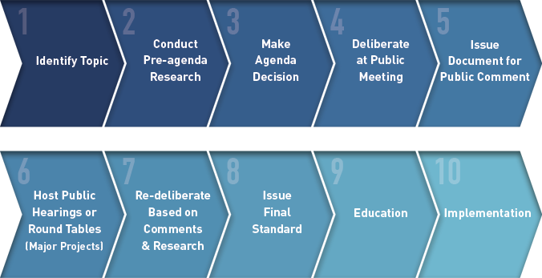
The Financial Accounting Standards Board (FASB) is an independent organization responsible for establishing and improving standards of financial accounting and reporting to ensure clarity, consistency, and transparency in the financial statements used by investors, creditors, and other stakeholders (FASB, 2025). One of its key contributions is the development and maintenance of the Accounting Standards Codification (ASC), which organizes all authoritative accounting principles that make up Generally Accepted Accounting Principles (GAAP). The Codification system organizes these principles into specific topics, subtopics, and section codes, making it easier for accounting professionals to locate, interpret, and apply the appropriate guidance to various financial reporting issues (FASB , 2025). This structure not only enhances accessibility but also ensures that financial professionals can efficiently adhere to the correct standards without confusion. The FASB follows a rigorous, transparent, and collaborative process when developing new accounting standards or updating existing ones. As shown in Figure 1, the process begins with identifying issues or areas of concern raised by the accounting community, including practitioners, investors, regulators, and other stakeholders. Once a topic is selected, the Board conducts extensive research and analysis to understand the implications and potential outcomes of different accounting treatments. This phase is followed by public deliberations, exposure drafts, and the solicitation of feedback through comment letters and hearings. The FASB also holds private roundtable discussions with industry experts to refine proposed standards before implementation. After final review and approval, the new accounting standard is published and incorporated into the Codification, accompanied by educational resources to help accountants properly apply the changes (FASB, 2025). Through this comprehensive process, the FASB ensures that financial reporting standards remain relevant, reliable, and responsive to the evolving needs of the global economy.
https://www.fasb.org/about-us/standard-setting-process
Figure 1:
While this may seem extensive, it all stems from the Sarbanes–Oxley (SOX) Act of 2002, which established the Public Company Accounting Oversight Board (PCAOB) ***. The SOX Act was created in response to the Enron corporate scandal, which is often considered “the most complex white-collar crime investigation in the FBI’s history” (FBI, n.d.). The Enron scandal involved widespread fraud and deception within the company, including hiding billions of dollars in debt to make the business appear more profitable than it actually was. A significant part of the scandal also involved Arthur Andersen LLP, Enron’s auditing firm and one of the largest accounting firms in the world at the time, which was accused of helping to cover up the wrongdoing (Clarke, 2005). The fallout from the scandal had a massive impact on the accounting profession. Public trust in accountants and auditors declined sharply, and the entire industry faced intense scrutiny. In response, the SOX Act introduced new laws and stricter regulations to restore confidence in financial reporting and ensure accountability. These laws required greater transparency from companies, stronger internal controls, and harsher penalties for corporate fraud. Over time, these changes helped rebuild trust and reinforce the importance of ethics, honesty, and accuracy in accounting.

AI in Accounting
AI has come in hot and fast into the business world, and by the looks of things is not slowing down anytime soon. This is why you see CPA firms investing in AI and making it part of the day to day for their company. Major firms, including the Big 4, have already invested over $9 billion (Sona, 2022) and things don’t look like they’re slowing down. And accounting firms are not the only businesses who are spending money on AI. As seen in Figure 2, in 2023 and 2024 around $60 billion was spent on generative AI globally by private investments. The 2024 spending is over 8.5 times higher than the money spent in 2022.
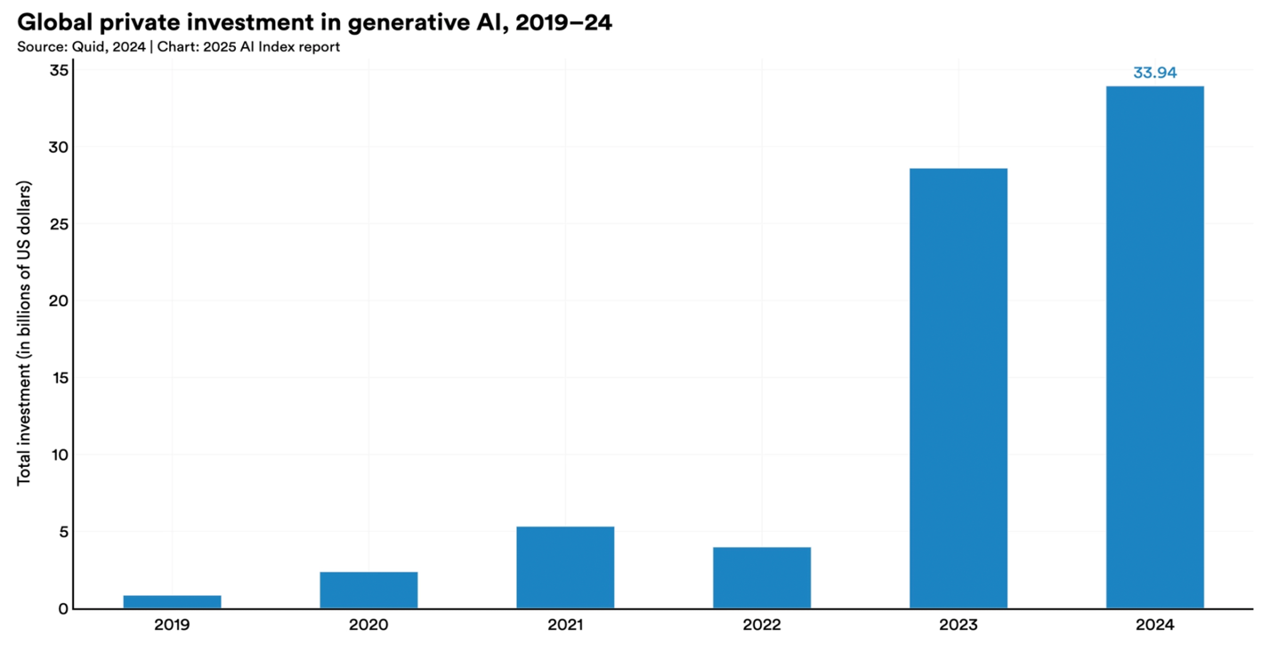
Figure 2:
The biggest debate in AI and how much it will change the work for an accountant is on the forefront of many accountants’ minds. There are two major parts of AI that are being considered, Narrow and Generative AI, both of these AIs will perform different tasks that will greatly benefit an accountant. Narrow AI which will handle the repetitive tasks for accountants, these repetitive tasks include counting inventory and reading contracts, as well as reading large amounts of data and extracting specific information that is needed from the data. (Eisikovits, Johnson , & Markelevich , 2025) Then there is Generative AI which will generate new content for accountants, this content could include drafting textual content (notes for financial systems) for accountants. (Eisikovits, Johnson , & Markelevich , 2025) This can seem overwhelming when talked about with no context, because if data can be found and notes can be written up for that data where does it leave accountants in this new age of AI? However, the introduction of these AI technologies does not necessarily mean that accountants will become obsolete. Instead, it represents a shift in focus from routine data collection and entry toward more analytical and interpretive responsibilities. There are many benefits for accountants in AI, because of Narrow and Generative AI, the busy work of the role is being streamlined. AI is allowing about 7.5 reduction in monthly close time (Church, 2025) and this is leaving room for accountants to put more creative into their work and pull from data across the world in a way that was never able to be done before. (LoBianco, Jialin Sun, & Zhao , 2025)
https://hai.stanford.edu/ai-index/2025-ai-index-report/economy

Diversity in Accounting Firms
The Big Four — Deloitte, PwC, EY, and KPMG — had a combined revenue of $212.1 billion (Big 4 Accounting Firms, 2025), and 16 accounting firms made over $1 billion in their most recent fiscal year (Barmewell, 2024). While the Big Four have dominated the accounting industry since 2002, when a fifth major firm collapsed due to the Enron scandal (Kenton, 2025), they are no longer the only appealing or influential option for accountants. Smaller and mid-tier firms have made notable impacts on the profession, offering strong career paths, specialized expertise, and diverse workplace cultures. These firms often provide accountants with greater flexibility and opportunities for growth that are not always available at the larger firms.
Work–life balance, in particular, has become one of the most important factors influencing where future accountants choose to work (Bagley, Dalton, & Ortegren , 2012). Recent research supports this shift in priorities, as shown in Figure 3, only about 45% of accounting students in a recent study indicated they were interested in pursuing a career with one of the Big Four firms. This suggests that the Big Four may not hold the same level of influence or appeal among the next generation of accountants as they once did. Instead, many students are seeking environments that better align with their personal values, offer manageable workloads, and provide a sense of purpose and balance, qualities often found in smaller or regional firms.
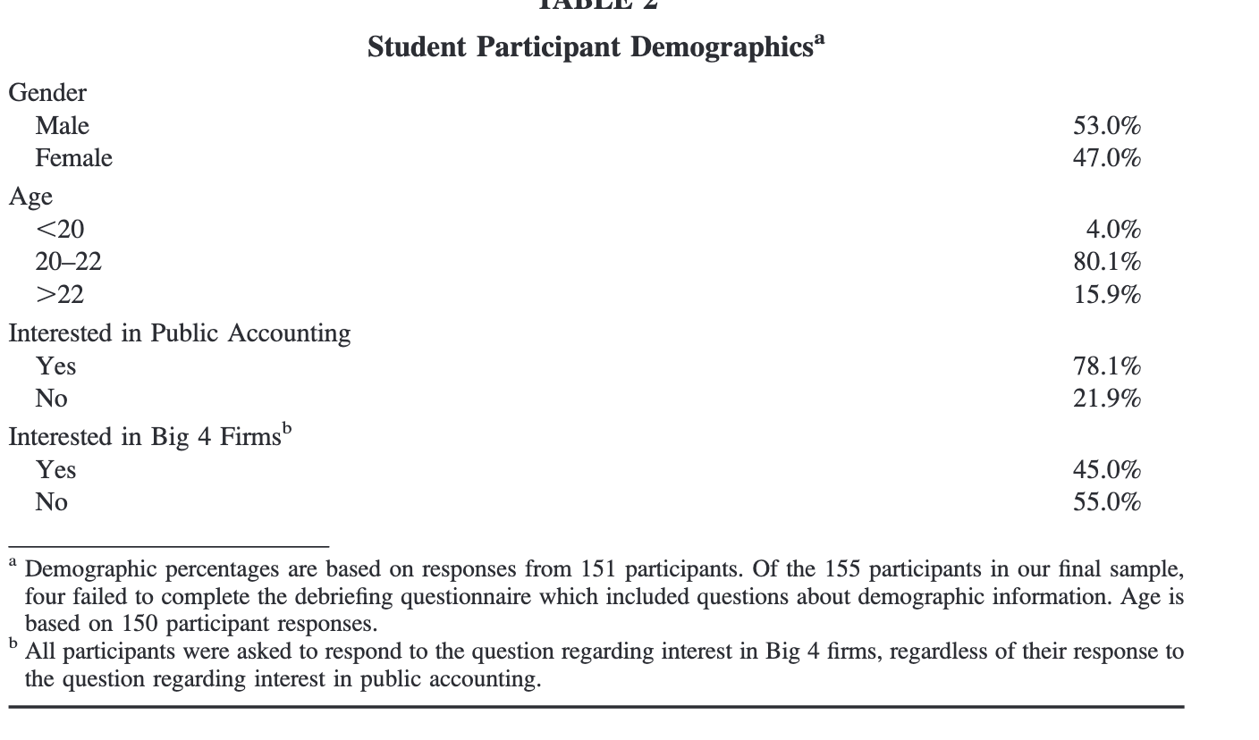
https://research.ebsco.com/c/veyqbh/viewer/pdf/orlohbqrjv
Figure 3:

Car, Riggs, & Ingram (CRI)

The History of CRI
CRI was founded 1997 when two highly respected firms merged together, this was in order to keep the firms ahead of the crowd in the growing accounting landscape. (CRI: Carr, Riggs, & Ingram, 2025) These ideals still stay true today as the company continues to expand, recently merging with Florence and Abroms & Associates. (CRI: Carr, Riggs, & Ingram , 2025) As shown in Figure 4, the company now has over 100,00+ clients and is located in the both the United States and Mexico.
https://www.criadv.com/wp-content/uploads/2025/04/cri-firm-facts-brochure.pdf
Figure 4:

Services Provided
CRI is a nationally recognized public accounting firm that provides a wide range of professional services to clients across multiple industries. CRI offers advisory, audit, and tax services, as well as various specialized consulting and support options designed to meet the diverse needs of businesses and organizations. Their advisory services include business consulting, valuation, technology solutions, risk management, and financial planning. The audit services focus on ensuring compliance, accuracy, and transparency for organizations of all sizes, while their tax division helps clients navigate complex tax laws, identify savings opportunities, and maintain regulatory compliance.
In addition to these main areas, CRI also offers extra add-on services that help clients strengthen their operations and adapt to changing business environments. These include forensic accounting, cybersecurity consulting, transaction advisory, and business succession planning. (CRI: Carr, Riggs, & Ingram , 2025) By providing such a comprehensive selection of services, CRI can support clients through every stage of their business, from start-up growth to long-term sustainability.
CRI serves a wide variety of industries, such as nonprofit organizations, government entities, healthcare, construction, real estate, manufacturing, and agribusiness. This can be seen in Figure 5, that breaks down the specialty fields of the firm. Their ability to work across so many fields allows them to bring valuable insight and experience to every engagement. Because of this wide service range, CRI is able to tailor its approach to each client’s specific needs and challenges. This adaptability helps clients make informed decisions, improve financial performance, and meet industry standards with confidence.
https://www.criadv.com/family-of-companies/
Figure 5:

Firm Size
Carr, Riggs & Ingram (CRI) has grown into one of the largest accounting firms in the United States, continuing to expand its footprint across multiple states. CRI generates approximately $306 million in annual revenue and employs around 2,000 professionals, maintaining a strong regional presence while serving clients nationally. (Zippia, 2025) CRI ranked No. 22 on its Top 100 Accounting Firms list, reporting revenues of $382 million after several recent mergers and expansions. (Cohn, 2022) This consistent growth demonstrates CRI’s ability to compete effectively within the upper tier of national firms while maintaining its client-focused culture.
When compared with the largest international accounting firms, CRI operates on a smaller scale but still plays a vital role within the mid-market segment of the profession. Firms such as Deloitte and PwC reported global revenues in the tens of billions—Deloitte at $70.5 billion and PwC at $55.4 billion—making them far larger in both reach and resources (Deloitte, 2025) (PwC, 2024). However, CRI’s strong regional focus and diversified service offerings allow it to compete successfully for clients who seek more personalized service and accessibility. CRI’s leadership continues to emphasize relationship-building and community involvement, two aspects that differentiate it from the larger, more globalized firms.
In terms of profitability and operational performance, CRI continues to strengthen its position by expanding into new markets and broadening its service range. (CRI: Carr, Riggs, & Ingram , 2025) Through its offerings in tax, audit, assurance, advisory, technology consulting, and industry-specific services, the firm is able to attract clients from various sectors including nonprofit, healthcare, construction, and government. (CRI: Carr, Riggs, & Ingram , 2025) This wide service range gives CRI a unique ability to support clients with both routine accounting needs and specialized business challenges. The firm’s growth through mergers and acquisitions, combined with its emphasis on partner accessibility and long-term client relationships, has helped sustain profitability and build a reputation for reliability and trust

Interview
An interview was conducted with Dana Alexander, a partner at Carr, Riggs, & Ingram (CRI). Alexander holds two distinguished credentials, Certified Public Accountant (CPA) and Certified Information Technology Professional (CITP). Her work primarily focuses on tax services for a wide range of nonprofit organizations, where she applies her knowledge and experience to help clients achieve financial transparency and compliance. Alexander earned her Bachelor of Arts in Accounting from the University of North Florida (UNF) and has accumulated over 17 years of professional experience in the accounting industry.
Alexander’s journey with CRI began at a career fair held at UNF, where she first discovered the firm. She was immediately drawn to CRI’s values, culture, and focus on professional growth. After the firm later went through a merger, Alexander stayed and gradually worked her way up to partner, demonstrating strong dedication and continuous professional development.
When she was preparing for her initial round of interviews after the career fair, Alexander made it a priority to research each company thoroughly to understand their missions, goals, and workplace environments. She also spent time practicing interview questions and reflecting on her own experiences so that she could communicate her strengths confidently. This preparation helped her succeed in multiple interviews; she received offers from three out of the five firms she met with. One of those offers came from CRI, where she has remained and built her long-standing career.
During her first internship, Alexander learned the majority of her business communication and client interaction skills. The experience provided her with hands-on learning opportunities, especially in how to communicate effectively in professional settings. Early in her internship, her client communications were closely monitored by partners to ensure accuracy, clarity, and professionalism. Over time, as her confidence and skill improved, she was given more independence to handle client interactions directly. Now, one of the most rewarding aspects of her communication is delivering good news to clients, specifically when audits or tax returns are successful, clean, and free of issues. She explained that moments like these are satisfying because they represent the culmination of months of hard work and collaboration.
However, Alexander noted that not all communication in accounting is easy or positive. The most challenging situations arise when there are complicated tax or audit issues that require extensive proofing and explanation. In those moments, she must communicate the challenges clearly and honestly while maintaining professionalism and client trust..
When discussing her personal strengths, Alexander stated that problem-solving is the skill she relies on most in her day-to-day work. Every client presents a unique situation, and no two cases are ever the same, which constantly challenges her to think critically and creatively. She explained that her firm often takes an “outside the box” approach, which includes team collaboration meetings and sometimes even conducting physical inventory checks to ensure accuracy in client records. These steps help maintain the reliability of information and reinforce CRI’s commitment to integrity and precision.
Although Alexander has achieved great success in her career, she also recognizes her biggest area for improvement—networking. She shared that while she has excellent relationships with her clients and colleagues, networking outside of her immediate professional circle does not come as naturally to her. Despite this, she continues to work on building stronger connections across the industry and within her community.
Part of Alexander’s role at CRI also involves a significant amount of crisis management, as accounting firms frequently encounter unexpected challenges or client concerns. She mentioned that she has to deescalate and manage difficult situations about once a week. These moments can involve anything from client misunderstandings to time-sensitive reporting issues. Her problem-solving mindset have allowed her to successfully navigate these situations while maintaining positive client relationships.
At CRI, partner evaluations are conducted three times per year by the partner in charge. These evaluations are informal in nature, but they focus on key performance areas such as client work and technical abilities. Another important topic discussed during these evaluations is community involvement, which has become increasingly emphasized at CRI. Alexander shared that CRI strongly encourages partners and employees to engage with their communities and give back whenever possible.
Outside of her work responsibilities, Alexander is deeply committed to community service. She currently serves on the board of The Lone Warrior Foundation, an organization that supports single parents battling cancer (Lone Warrior Foundation, 2025). She expressed that her involvement with this foundation is fulfilling as it allows her to use her time and resources to help others in need.
To stay informed about current developments in the accounting profession, Alexander regularly reads the Journal of Accountancy, which she finds to be the most useful and up-to-date source for industry news, professional standards, and best practices. She believes that staying educated and informed is essential for all accountants, especially in a field that constantly evolves with new technology and regulations.
Overall, Dana Alexander’s career path and insights reflect the importance of dedication, adaptability, and continuous learning in the accounting profession. Her journey from a UNF student to a partner at a respected accounting firm highlights how strong communication, a problem-solving mindset, and a commitment to professional ethics can lead to long-term success.

Sample Writing

Sample 1: Email Correspondence
The first sample writing is about the setup for an annual gala hosted by The Lone Warrior Foundation, a nonprofit organization that supports veterans and their families. Dana Alexander, who serves on the organization’s board, received an email confirming the booking of a table for the event. The gala is one of the foundation’s most important fundraisers of the year, and selling tables is a major way they raise money to support their programs. Each table represents not just a seat at a formal dinner, but also a contribution to the foundation’s mission of helping those who have served their country. The confirmation email ensures that everything is in order for the event and helps the organizers manage seating arrangements, sponsorships, and donations efficiently.
In professional business communication, emails play a crucial role in keeping information organized and easily accessible. They allow people to exchange important details quickly, maintain a written record of agreements, and communicate in a clear and professional tone. A well-written email can demonstrate respect, organization, and attention to detail. All essential qualities in the business world. Using email also helps professionals like Dana Alexander coordinate with event planners, sponsors, and other board members without confusion. In this way, email communication is not just a convenience, it’s a vital tool for maintaining professionalism and ensuring the success of major events like the Lone Warrior Foundation’s annual gala.


Sample 2: Business Card

The second sample writing focuses on a business card, which serves as a quick and effective form of professional communication. A business card provides key details such as a person’s name, title, company, phone number, and email address. It may look small and simple, but it carries a lot of meaning. The way information is arranged, the choice of font, and even the spacing all reflect how organized and professional the individual or business is. Business cards are designed to make a strong first impression, showing that the person values clarity, precision, and professionalism. In many cases, a well-designed business card can set the tone for future interactions and help build trust between professionals.
The colors scheme used on a business card help express a formal and confident image. The grayish blue gives off a sense of calm, balance, and sophistication, while also representing loyalty, stability, and trust. The color scheme creates a clean and polished design that feels both modern and respectful. These colors are often chosen by businesses that want to appear dependable and professional without being too flashy. The grayish blue sends a subtle message, it tells others that the person or organization behind the card is serious, reliable, and ready to do business with integrity.

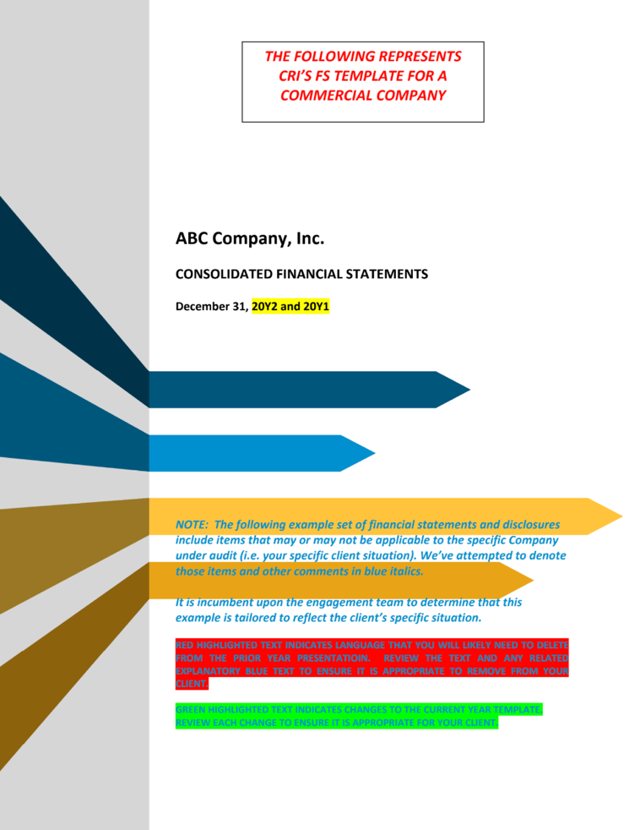
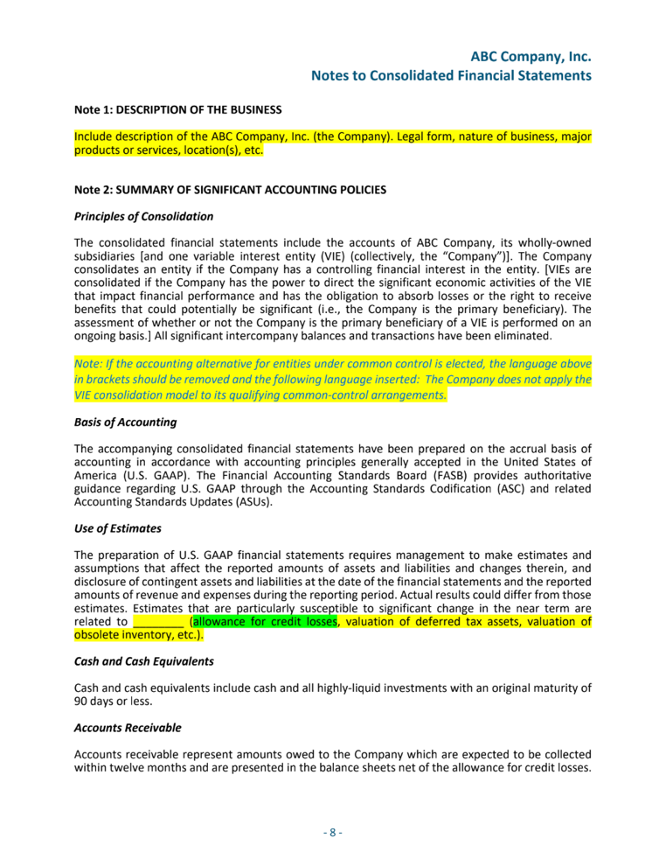
Sample 3: Consolidated Financial Statements Template

The third sample writing focuses on the use of templates that are sent out by a company to communicate with clients. Templates are pre-designed documents or messages that help businesses keep their communication clear, organized, and consistent. They are often used for emails, invoices, thank-you letters, or announcements. Using templates saves time and ensures that every message follows the same professional tone and format. This consistency helps the company appear more reliable and well-structured, which can build trust with clients.
Templates also make communication more efficient and accurate. Instead of creating a new message from scratch every time, employees can focus on customizing only the details that matter, such as names, dates, or project information. This approach helps reduce errors and keeps the company’s image consistent across all types of communication. When clients receive messages that follow a familiar structure, it creates a sense of stability and dependability. In professional business communication, that kind of trust can make a lasting difference in how clients view and respect the company.

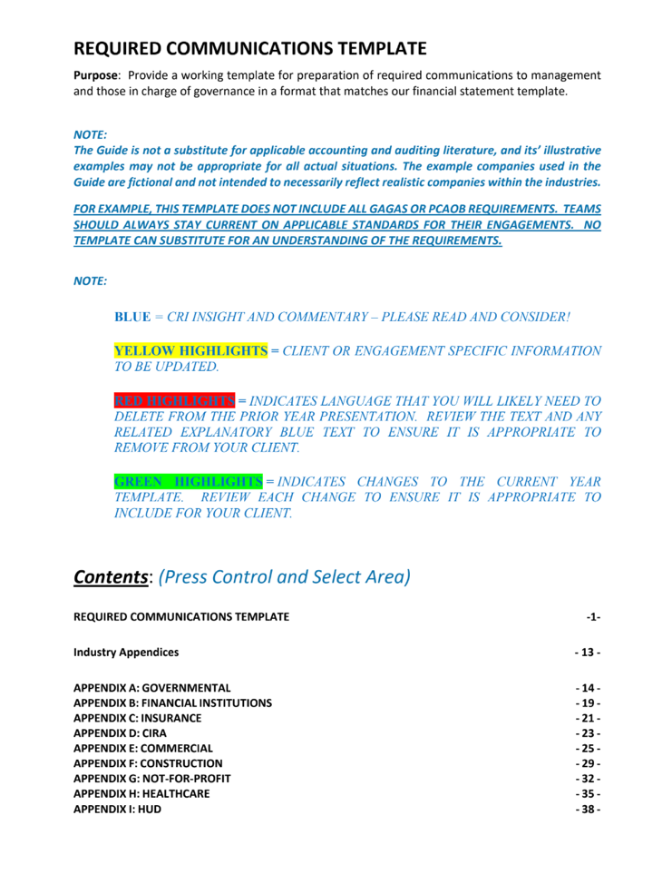
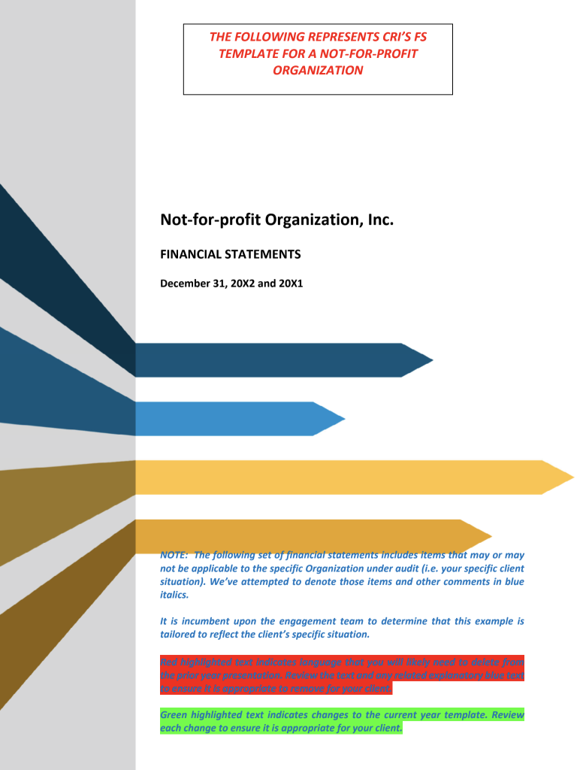
Sample 4: Nonprofit Notes of Financial Statements Template

The fourth sample writing focuses on the nonprofit notes for financial statements that are sent from the corporate office. These notes include important updates that employees need to review before finalizing reports. The document uses green highlights to show where new information has been added and red highlights to mark what has been removed from the previous year. Yellow highlights are used for client or engagement-specific information that needs to be updated, while blue highlights represent CRI insight and commentary that provide additional context or professional guidance. This color-coded system helps employees quickly identify changes without confusion or wasted time. It also keeps everyone on the same page, which is especially important when dealing with financial data. By organizing the document in this way, the company shows a commitment to clarity, accuracy, and professionalism.
This type of formatting reflects strong professional business communication. It demonstrates how even small design choices, like using color to show edits, can make complex information easier to understand. Clear communication is essential in the business world, especially when it involves numbers that affect decisions and planning. The color highlights act as visual signals that guide employees to what matters most. This thoughtful structure not only saves time but also reduces mistakes, showing that the organization values precision and teamwork. In a professional setting, using formatting like this sends a powerful message: the company cares about both efficiency and effective communication.

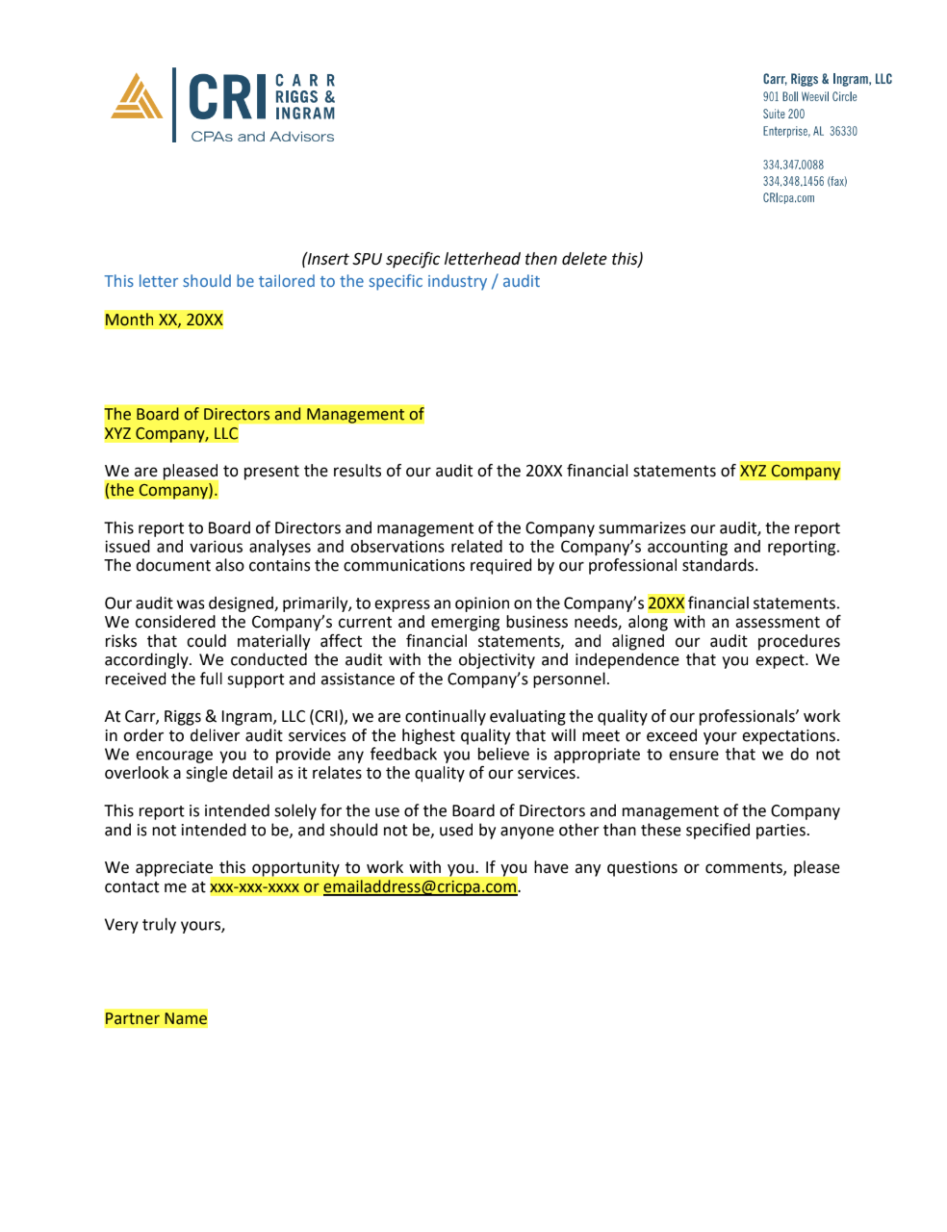
Sample 5: Client Correspondence Email Template

The fifth sample writing focuses on the email template used by the company when contacting clients about a completed audit. This template is designed to maintain consistency and professionalism across all communications. Every employee uses the same format when sending these messages, which helps ensure that each client receives clear, accurate, and respectful correspondence. The structure of the template includes a formal greeting, a brief summary of the completed audit, and the necessary contact information for follow-up questions. By following a uniform layout, the company demonstrates organization, attention to detail, and reliability—all qualities that build trust between the firm and its clients.
Using a standard template also reflects strong business communication skills. It keeps the message professional and avoids errors that might occur if each employee wrote their own version. The consistent tone and structure show that the company values clarity and efficiency, two key parts of successful client relations. This approach allows the firm to communicate important financial information with confidence while maintaining a polished and respectful image. In professional settings, such templates are more than just time-savers—they are tools that represent the company’s commitment to quality communication and client satisfaction.

Summary
The accounting industry continues to play a key role in maintaining the financial health of businesses and organizations. It remains a stable and respected profession due to its importance in financial reporting, auditing, and advising companies through both strong and weak economic periods. Accountants are expected to keep up with changing standards and technology while holding certifications such as Certified Public Accountant (CPA) or Certified Management Accountant (CMA), which improve their expertise and credibility (Tobin & Carlton, 2025). The U.S. Department of Labor (2025) reports that the median annual salary for accountants in 2024 was $81,680, showing that accounting offers both steady employment and competitive pay. These professionals rely on technical skills like bookkeeping and data analysis, but also on communication and problem-solving to support business decisions effectively (Tobin & Carlton, 2025).
Carr, Riggs & Ingram (CRI) is one of the largest accounting firms in the United States, known for its wide range of services and strong client relationships. Founded in 1997 through the merger of two established firms, CRI has expanded across multiple states and even into Mexico (CRI: Carr, Riggs, & Ingram, 2025). The firm offers audit, tax, and advisory services, along with specialized options such as forensic accounting, cybersecurity, and succession planning. CRI generates about $306 million in annual revenue and employs over 2,000 professionals, ranking 22nd among national accounting firms (Zippia, 2025) (Cohn, 2022). Its large service range allows CRI to support clients from many industries including healthcare, government, construction, and nonprofit sectors, helping organizations improve financial performance while ensuring compliance with accounting regulations (CRI: Carr, Riggs, & Ingram , 2025).
An interview with Dana Alexander, a partner at CRI, highlights how communication and adaptability are key to success in accounting. Alexander, who holds both CPA and Certified Information Technology Professional (CITP) credentials, began her career at CRI after meeting the firm at a University of North Florida career fair. Over her 17 years with the company, she has advanced to partner by combining technical skill with problem-solving and leadership. She shared that her most rewarding moments come from telling clients that their audits or tax returns are successful and accurate, while her greatest challenges arise when dealing with complex tax issues or client crises. Alexander also values community involvement and serves on the board of The Lone Warrior Foundation, which helps single parents battling cancer (Lone Warrior Foundation, 2025). Her career shows how dedication, professionalism, and ongoing learning can lead to long-term achievement in the accounting field.

Conclusion
The accounting field continues to offer strong career opportunities for professionals who are skilled, adaptable, and committed to continuous learning. Firms like Carr, Riggs & Ingram (CRI) demonstrate how accounting goes beyond numbers—it involves communication, teamwork, and problem-solving to help clients achieve success. The interview with Dana Alexander and the analysis of CRI’s firm structure show the value of professionalism, leadership, and service in the industry. The writing samples included throughout this project reflect these same qualities, showcasing research, organization, and clarity in communicating complex information—skills that are just as essential in professional accounting as they are in written work. Together, these samples illustrate how effective writing and accounting both rely on accuracy, attention to detail, and clear communication to build trust and deliver results.

Thank You Note

References
Bagley, P., Dalton, D., & Ortegren , M. (2012). The Factors that Affect Accountants' Decisions to Seek Careers with Big 4 versus Non-Big 4 Accounting Firms. Accounting Horizons.
Barmewell, J. (2024, August 20 ). ‘Billion-Dollar Club’ Has Its 16th Member Accounting Firm. Retrieved from CPA Practice Advisor: https://www.cpapracticeadvisor.com/2024/08/20/billion-dollar-club-has-its-16th-member-accounting-firm/108946/
Big 4 Accounting Firms. (2025). Big 4 Accounting Firms Ranking 2025 . Retrieved from Big 4 Accounting Firms : https://big4accountingfirms.com/big-4-accounting-firms-ranking/
Calibre CPA Group . (2020, October 1). Generally Accepted Accounting Principles . Retrieved from Nonprofit Accounting Basics : https://www.nonprofitaccountingbasics.org/accounting-bookkeeping/generally-accepted-accounting-principles
Church, Z. (2025, August 5). How generative AI can make accountants more productive . Retrieved from MIT Sloan School : https://mitsloan.mit.edu/ideas-made-to-matter/how-generative-ai-can-make-accountants-more-productive#:~:text=A%2012%25%20increase%20in%20general,security%20issues%20and%20job%20displacement.
Clarke, T. (2005). Accounting for Enron: shareholder value and stakeholder interests. Retrieved from Corporate Governance: An International Review: https://doi.org/10.1111/j.1467-8683.2005.00454.x
Cohn, M. (2022, 12 13). CRI expands to South Carolina . Retrieved from Accounting Today: https://www.accountingtoday.com/news/cri-expands-to-south-carolina-by-adding-lanning-group?utm_source=chatgpt.com
CRI: Carr, Riggs, & Ingram . (2025, October 29). CRI Strengthens Alabama Footprint with Abroms & Associates, PC. Retrieved from CRI: Carr, Riggs, & Ingram : https://www.criadv.com/news/top-25-firm-carr-riggs-ingram-expands-operations-in-north-alabama/
CRI: Carr, Riggs, & Ingram . (2025). Services . Retrieved from CRI Services : https://www.criadv.com/#advisory-specialty
CRI: Carr, Riggs, & Ingram. (2025). CRI: Your Solution Team . Retrieved from CRI: Carr, Riggs, & Ingram: https://www.criadv.com/about/#:~:text=CRI%20was%20born%20in%201997,opportunities%E2%80%94and%20they%20seized%20them.
Deloitte. (2025, 9 30). Deloitte reports FY2025 revenue . Retrieved from Deloitte: https://www.deloitte.com/global/en/about/press-room/global-revenue-announcement.html?utm_source=chatgpt.com
Eisikovits, N., Johnson , W. C., & Markelevich , A. (2025). Should Accountants Be Afraid of AI? Risks and Opportunities of Incorporating Artificial Intelligence into Accounting and Auditing. Accounting Horizons, Business Source Complete.
FASB . (2025). FASB Financial Accounting Standards Board. Retrieved from FASB: https://www.fasb.org/
FASB. (2025). Standard-Setting Process. Retrieved from FASB Financial Accounting Standards Board: https://www.fasb.org/about-us/standard-setting-process
FASB. (2025). Welcome to the Accounting Standards Codification. Retrieved from Accounting Standards Codification: https://asc.fasb.org/Home
FBI. (n.d.). Enron: The collapse of the energy company Enron in December 2001 precipitated what would become the most complex white-collar crime investigation in the FBI’s history. Retrieved from FBI: https://www.fbi.gov/history/famous-cases/enron
Kenton, W. (2025, August 26). The Big 4 Accounting Firms: An Overview . Retrieved from Investopedia: https://www.investopedia.com/terms/b/bigfour.asp#:~:text=Arthur%20Young%20combined%20with%20Ernst,scandal%2C%20the%20five%20became%20four.
LoBianco, A., Jialin Sun, K., & Zhao , X. (2025, September). How Artificial Intelligence May Impact the Accounting Profession. Retrieved from The CPA Journal : https://www.cpajournal.com/2025/09/08/how-artificial-intelligence-may-impact-the-accounting-profession/
Lone Warrior Foundation. (2025). Retrieved from Lone Warrior Foundation: https://www.lonewarriorfoundation.com/
PwC. (2024, 10 29). PwC global revenues rise to US$55.4 billion. Retrieved from PwC: https://www.pwc.com/gx/en/news-room/press-releases/2024/pwc-global-revenues-rise-to-us-55-4-billion.html?utm_source=chatgpt.com
Sona, V. S. (2022). The Big Four's Implementation of Artificial Intelligence . Retrieved from Academia: https://www.academia.edu/82351797/The_Big_Fours_Implementation_of_Artificial_Intelligence
Tobin, J. M., & Carlton, G. (2025, October 14). What Is an Accountant? . Retrieved from Accounting.com: https://www.accounting.com/careers/overview/
U.S. Department of Labor. (2025, August 28). Occupational Outlook Handbook, Accountants and Auditors. Retrieved from U.S. Bureau of Labor Statistics: https://www.bls.gov/ooh/business-and-financial/accountants-and-auditors.htm
Zippia. (2025). Carr, Riggs & Ingram reveune . Retrieved from Zippia The Career Expert: https://www.zippia.com/carr-riggs-ingram-careers-18240/revenue/?utm_source=chatgpt.com

