Connecting with the Community
Pouring back into the community while the team is away to keep fans engaged.
Eubanks, Morgan
Jacksonville Jaguars
Table of Contents
Executive Summary 2
Introduction 3
The Jaguars and their Future 4
Downtown Jacksonville’s Future 4
The Local Teams Surrounding Jacksonville 5
The Icemen 5
The Jumbo Shrimp 5
Jaguars Connecting with the Community 6
Ideas for Upcoming Seasons 2026 – 2028 6
Works Cited 10

Executive Summary

As Jacksonville prepares for the future of its NFL franchise with a new state-of-the-art stadium scheduled for completion in 2028, the city faces a unique challenge—and opportunity. With seat reductions beginning in 2026 and a full team relocation during the 2027 season, the absence of Jaguars home games will leave a significant gap in the local sports landscape. However, this moment also presents a powerful chance to reinforce the Jaguars' presence and build long-term fan loyalty by partnering with the city’s other professional teams: the Jacksonville Jumbo Shrimp (MiLB) and the Jacksonville Icemen (ECHL).
These teams are already deeply rooted in the community. The Jumbo Shrimp are Jacksonville’s longest-tenured sports program and continue to grow attendance year after year, offering affordable, family-friendly entertainment. Meanwhile, the Icemen have quickly become a fan-favorite, setting new attendance records and earning national praise from figures like Jason Kelce. Both teams offer strong platforms that enable the Jaguars to maintain visibility and connect with fans during the construction of their new stadium.
Research supports this strategy: promotional theme nights, giveaways, and cross-branding efforts have proven to increase attendance by up to 14%, and for every dollar spent on a quality giveaway, attendance can jump by nearly 2,700 fans. The Jaguars have already seen early success with local events like the Jaguars 5K, and by expanding efforts—such as hosting “Jags Nights” at Icemen and Jumbo Shrimp games, organizing community events like Duval Days, and planning a city-wide Half Marathon—the team can continue growing its presence even off the field.

Introduction

The Jacksonville Jaguars belong to one of the smallest media markets in the NFL and are located in one of the most fluid cities in the country. With plans for stadium seat reductions beginning in 2026 and a complete relocation during the 2027 season while construction on a new stadium takes place, Jacksonville is poised to be without its NFL team for a significant period. This temporary absence presents an opportunity for Jacksonville’s other professional sports teams—the Jacksonville Jumbo Shrimp (Triple-A affiliate of the Miami Marlins) and the Jacksonville Icemen (ECHL affiliate of the Buffalo Sabres)—to step up and assume a larger role in the city’s sports landscape.
The Jumbo Shrimp, formerly known as the Suns, are Jacksonville’s longest-standing professional sports team, having played their inaugural season in 1962. The team has seen consistent growth in attendance since 2019 (Kornberg, 2019), thanks to affordable ticket prices, family-friendly promotions, and community engagement. Similarly, the Jacksonville Icemen have gained serious traction in recent years, setting a new franchise attendance record during the 2023–2024 season (Swisher, 2024). This upward trend in local sports engagement contrasts sharply with the Jaguars, who saw a staggering 73% drop in ticket sales for the 2025 season, attributed mainly to a disappointing 2024 season record (Burgess, 2025).
Despite these challenges, the Jaguars remain Jacksonville’s only franchise competing at the highest professional level in their respective sport, and their brand still carries significant weight in the city. However, with their temporary absence from the local scene, it will be crucial for the Jaguars to maintain visibility and community connection. One strategy would be to form strong partnerships with the Jumbo Shrimp and Icemen, using these teams as marketing agents and engagement platforms during the transition. This cross-team collaboration could help preserve the Jaguars’ fan base and even expand it, especially among younger and more casual sports fans.

The Jaguars and their Future
Figure 1
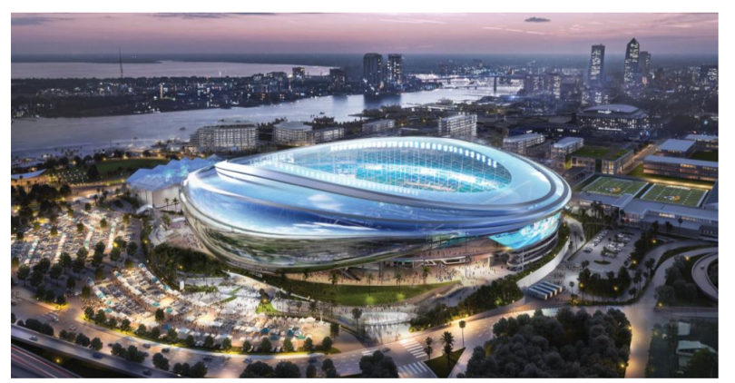
The Jaguars are gearing up for the next 5 years to become the next major franchise team within the NFL. Leading the team are quarterback Trevor Lawrence and new head coach Liam Cohen. Who have already brought the team to the same amount of wins this season (4-1) compared to last season (4-13). This will give the Jaguars the moral boost they need before they start restricting seats and leaving for a year.
Figure 2
https://www.jaguars.com/stadiumofthefuture/
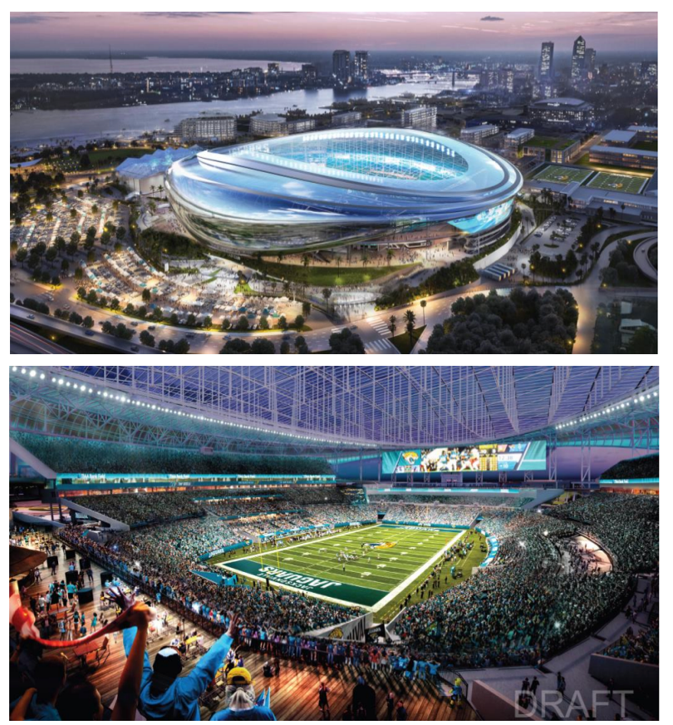
The next bright thing for the Jaguars' future is their brand-new stadium, scheduled for completion in August 2028. As shown in the mockups (Figure 1 and Figure 2), the new stadium will be more innovative and will have an increased space, with more amenities for fans to enjoy (City of Jacksonville Florida and Jacksonville Jaguars, 2024). This new stadium will also enable the Jaguars to host a variety of events, generating revenue for the city, including concerts and the iconic Florida vs. Georgia game. Georgia game, and much more. This will help the stadium become more than just a place for the team to play, but a proper attribution to the city and help build up the city.
https://www.jaguars.com/stadiumofthefuture/

Downtown Jacksonville’s Future
As construction on the new stadium progresses, downtown Jacksonville is undergoing a major revitalization with several key developments designed to complement the stadium and transform the urban core. This includes four new hotels—among them a Hard Rock Hotel and a luxury Four Seasons—alongside the creation of Pearl Square, a 2+ million-square-foot mixed-use district led by Gateway Jax with over $750 million in investment. (Gateway Jax, 2025). Pearl Square will feature more than 1,250 residential units, 200,000 square feet of retail space anchored by a new Publix, and an acre of open public space for community use. As downtown Jacksonville continues to boom, it will be important for the Jaguars to focus on their fan base and keep fans loyal during these construction years.

The Local Teams Surrounding Jacksonville

Jacksonville is home to multiple professional teams that compete at various levels. The teams include the Jacksonville Armada, the Jacksonville Sharks, the Icemen, and the Jumbo Shrimp. All of these teams play in the same city as the Jacksonville Jaguars, just on a much smaller scale. This gives them the unique opportunity to connect with the city on a more local level. The Jacksonville Armada plays at the University of North Florida, one of the three schools in Jacksonville where you can earn your college degree. The Sharks play in downtown Jacksonville, bringing another football team to the city. And because these venues are smaller, they allow for lower ticket prices, which in turn makes more fans eager to engage.

The Icemen
In February 2017, professional hockey officially returned to Jacksonville when the ECHL approved the relocation of the Icemen to the city. The team hired Jason Christie, the winningest coach in ECHL history, and soon after announced a partnership with the Winnipeg Jets. Even though the team had a slow start on the ice, fans were excited just to have hockey back and packed the Veterans Memorial Arena. In their second season, the Icemen made the playoffs, but it was what happened off the ice that really helped the team grow. In 2019, local businessman Andy Kaufmann bought the team and brought in other big-name investors like Tim Tebow, Myles Jack, Daniel Murphy, and Reggie Hayward. They also purchased the old Jacksonville Ice & Sportsplex and started a big renovation project to turn it into the Community First Igloo. In 2021, the team signed a two-year NHL affiliation with the New York Rangers and hosted the ECHL All-Star Classic, which garnered significant attention. (Swisher, 2021) The Icemen have led the ECHL in attendance for two consecutive years, breaking records with a crowd of over 14,000 fans in one game. They also extended their lease to stay in Jacksonville through the 2030–31 season (Swisher, 2024). With all this success, it could be an excellent time for the Jaguars to team up with the Icemen during the Jaguars' time away from the city. A partnership could help both teams and bring even more excitement to local sports fans.

The Jumbo Shrimp
The Jacksonville Jumbo Shrimp are the city’s longest-running and most established professional sports team, holding a special place in the community for generations. In 2023, they drew a total attendance of 347,723 fans and averaged 5,114 people per game—an increase from 4,974 in 2022. (Reichard, 2023) With home game tickets starting at just $5, games at VyStar Ballpark are an affordable, family-friendly way to bring the community together. The stadium itself can hold over 11,000 fans, offering plenty of room for attendance to continue growing, especially with the right partnerships and promotions. As a team that’s committed to staying in Jacksonville through at least 2033, the Jumbo Shrimp represent consistency and tradition in the city’s sports scene. Their long history and loyal fanbase make them an ideal partner for the Jaguars, especially while the Jags are temporarily playing out of town during stadium renovations.

Jaguars Connecting with the Community

While the Jaguars are the flagship professional team in Jacksonville, they’ve struggled over the years to fully tap into the local market and expand their fan base. From 2006 to 2024, ticket sales have remained relatively steady, showing only slight increases or decreases depending on the team's performance. Significant drops in attendance occurred during back-to-back losing seasons (2013–2015 and 2018–2019), as well as during the COVID-19 pandemic in 2020, as shown in Figure 3. Despite occasional playoff runs and star players, the team has yet to consistently capture the full attention and support of the region, showing there's still untapped potential in the Jacksonville sports market. 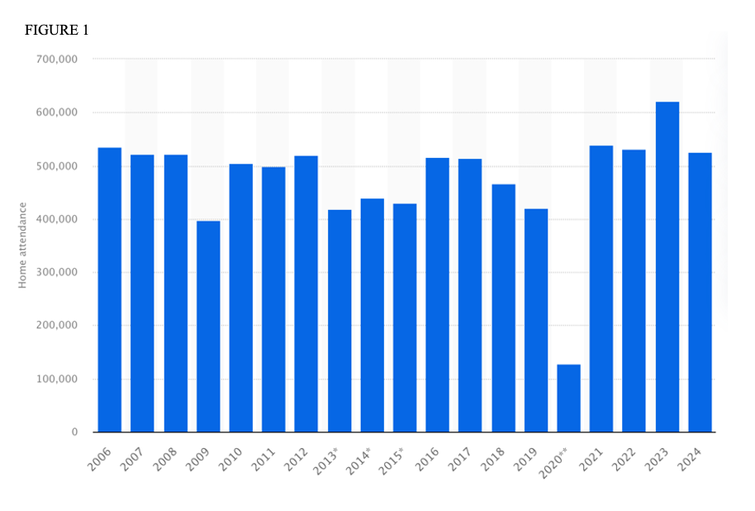
Figure 3
https://www.statista.com/statistics/197366/nfl-regular-season-home-attendance-of-the-jacksonville-jaguars-since-2006/
Total regular season home attendance of the Jacksonville Jaguars in the NFL from 2006 to 2024

Ideas for Upcoming Seasons 2026 – 2028

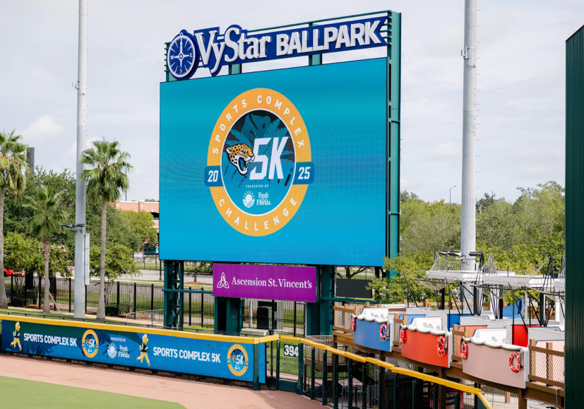
With the new seasons approaching and the Jaguars undergoing significant renovations, which will limit seating for a year and keep the team away for another, it's clear that attendance and fan involvement will decline. This is where other teams in the area can start investing in the program and partnering with the flagship team in Jacksonville. This will result in a mutualistic partnership, allowing all teams to thrive. The two teams with the largest resources and in a great position to do this are the Jacksonville Icemen and the Jumbo Shrimp. The Icemen have been on a continuous roll, with impressive runs and, more notably, being recently called out by Jason Kelce, a well-established retired football player for the Eagles, for being “incredible” on his podcast, New Heights, which averages 1.9 million listeners per episode. While the Jumbo Shrimp have not been given the same publicity stunt, they are in the top 30% (Reichard, 2023) for attendance across all MiLB teams and also recently hosted the Jaguars 5k, which allowed fans to run through the Jumbo Shrimp stadium while being shown on the jumbo screen, as shown in Figure 4.
Figure 4
https://www.jaguars.com/photos/k000473-experience-jacksonville-2025-jaguars-5k-race#dd28f500-65f3-48fd-9d1a-f61c5c26dc02
The 5k was a success, attracting over 800 participants, not including vendors or those cheering on friends and family. This highlights the potential for events hosted and supported by the Jaguars and other teams in the city. Some other ideas that would be low-cost for the Jaguars and be hosted by the different teams:
- Jags Night at the Igloo is an event that Jaxson de Ville and the Roar could participate in. Typically held the night before a game (Saturday nights), it creates a family-friendly environment, with fans showing their support for the Jaguars through a buy-in.
- Teal Out at VyStar Ballpark could be an event held during a Jumbo Shrimp game at the ballpark. Scampi, Southpaw, and Jaxson de Ville could all be attending the game, and they might even bring the D Line for the Jaguars for extra support and to show out for the team. Fans would be encouraged to wear teal, and to show extra support for the Jumbo Shrimp, teal t-shirts with the Jumbo Shrimp logo could be made and handed out to the first 100 attendees.
- Duval Days at Local Venues are events where teams’ mascots are invited to local businesses to garner support. These events can range from elementary to top-notch and go all out. This would depend on the venue size, the amount of money the teams are willing to spend, and their estimated attendance. This is also a great way to highlight local communities, as the Jaguars' investment in the community will ultimately benefit them.
- Sports Complex Half Marathon, with the success of the 5k and the Gate River Run (which is a 15k), a half-marathon in Jacksonville is something that the community would greatly appreciate. This is an event that every team in Jacksonville can participate in, with different mile markers sponsored by various local teams. This would also enable local businesses to shine by establishing cheer stations along the course and providing volunteer support at water booths. This race could again run through VyStar Ballpark as a finishing place, but also go around the VyStar Memorial Arena, Maxwell Coffee House, the Florida Theater, down the St. Johns River, and over two of the bridges in Jacksonville. Logistically, a half-marathon requires covering a lot of ground, which allows much of downtown Jacksonville to be part of the course, highlighting the Jaguars and other teams in the area.
- Season Ticketholder Nights, while the team is away, it will be essential to focus on the fans who have stayed and continued to be season ticketholders even with the stadium closed. There could be special event nights, either at an extra price or by signup, where the Jaguars open up the stadium and walk fans around to give them a first look at the new home of the Jacksonville Jaguars. The night can end in a local restaurant or bar, where Jaxon de Ville and the Roar would be to greet fans. This vital night will allow fans to realize how important they are to the program, generate buzz about the new stadium, and get the city excited.
Special events, such as theme nights and promotional giveaways, could have a significant positive impact on the Jaguars and any partner teams involved. Research shows these events aren't just fun—they drive real results. A 2008 study found that promotional games led to a 14% increase in average attendance for MLB teams. (Browning & DeBolt, 2008) Non-price promotions, such as theme nights or fan appreciation days, were even more effective on weekdays, when crowds are typically smaller. This means that hosting unique events during less popular games can help fill more seats. Giveaways are also a powerful tool—especially when paired with themed nights. In fact, one study found that for every dollar spent on a giveaway item like a bobblehead, attendance jumped by an average of 2,688 fans. Notably, 75% of fans expect a giveaway on theme nights, indicating that these events not only attract fans but also meet their expectations. (Burns, 2022) For the Jaguars and other local teams, such as the Icemen and Jumbo Shrimp, collaborating on well-planned special events could significantly boost attendance, foster deeper fan engagement, and help fill the gap when the Jaguars are away from their home stadium.

Conclusion

As Jacksonville enters a pivotal moment of growth—with a new stadium, downtown revitalization, and increasing momentum around local sports—now is the time for the Jaguars to deepen their roots in the community. While the temporary absence of home games may create a disconnect, it also presents an opportunity for stronger, more meaningful engagement. By collaborating with local teams like the Jumbo Shrimp and Icemen, the Jaguars can maintain visibility, grow their fan base, and contribute to a united sports culture in Jacksonville. To take full advantage of this opportunity, the Jaguars should act by January 2026 to establish formal partnerships, launch co-branded events, and implement a city-wide fan engagement strategy. This approach ensures that the team remains top-of-mind, builds long-term loyalty, and returns to a stronger, more connected fanbase in 2028.

Works Cited
Browning, R. A., & DeBolt, L. S. (2008, March 14). The Effects of Promotions on Attendance in Professional Baseball. Retrieved from The Sport Journal: https://thesportjournal.org/article/the-effects-of-promotions-on-attendance-in-professional-baseball/#:~:text=The%20positive%20effects%20on%20attendance,cap%20giveaways%2C%20and%20autograph%20sessions.
Burgess, C. (2025, January 6). Jacksonville Jaguars losing season makes sales plummet at local sports store. Retrieved from First Coast News : https://www.firstcoastnews.com/article/news/local/jacksonville-jaguars-losing-season-sales-plummet-local-sports-store/77-6e3f526b-a4af-46d7-90fc-718a74af04fa#:~:text=Local%20News-,Jacksonville%20Jaguars%20losing%20season%20makes%20sales%20plummet%20at%20l
Burns, M. J. (2022, April 28). Dogs and Disney: Sports ‘Theme Nights’ Are a Crucial Tool in Bringing Crowds Back After COVID. Retrieved from Morning Consult Pro : https://pro.morningconsult.com/trend-setters/sports-theme-nights-attendance-covid
City of Jacksonville Florida and Jacksonville Jaguars. (2024, May). Stadium of the Future. Retrieved from Jaguars: https://www.jaguars.com/stadiumofthefuture/
Gateway Jax. (2025). Retrieved from Pearl Square : https://www.pearlsquare.com/
Kornberg, S. (2019, August 27). MiLB. Retrieved from https://www.milb.com/news/gcs-310348164
Reichard, K. (2023, October 16). 2023 MiLB attendance by average . Retrieved from Ballpark Digest : https://ballparkdigest.com/2023/10/16/2023-milb-attendance-by-average/
Statista. (2025, March 3). Total regular season home attendance of the Jacksonville Jaguars in the NFL from 2006 to 2024 [graph]. Retrieved from ESPN.com: https://www.statista.com/statistics/197366/nfl-regular-season-home-attendance-of-the-jacksonville-jaguars-since-2006/
Swisher. (2021, December 30). Boldly Jacksonville: A Look Back at the Teams that Encompass Jacksonville’s Storied Hockey History. Retrieved from Jacksonville Icemen: https://jacksonvilleicemen.com/news/2022/12/boldly-jacksonville-a-look-back-at-the-teams-that-encompass-jacksonville-s-storied-hockey-history
Swisher. (2024, May 21). Boldly Jacksonville, Presented by Swisher: Recapping the Jacksonville Icemen’s 2023-24 Season. Retrieved from Jacksonville Icemen: https://jacksonvilleicemen.com/news/2024/05/boldly-jacksonville-presented-by-swisher-recapping-the-jacksonville-icemens-2023-24-season

